# Point-to-Point Protocol (PPP)

## The Point-to-Point Protocol (PPP) uses a lifecycle shown in the state diagram in figure 2. Draw a diagram that associates the frames exchanged between to endpoints as every step in the state diagram.

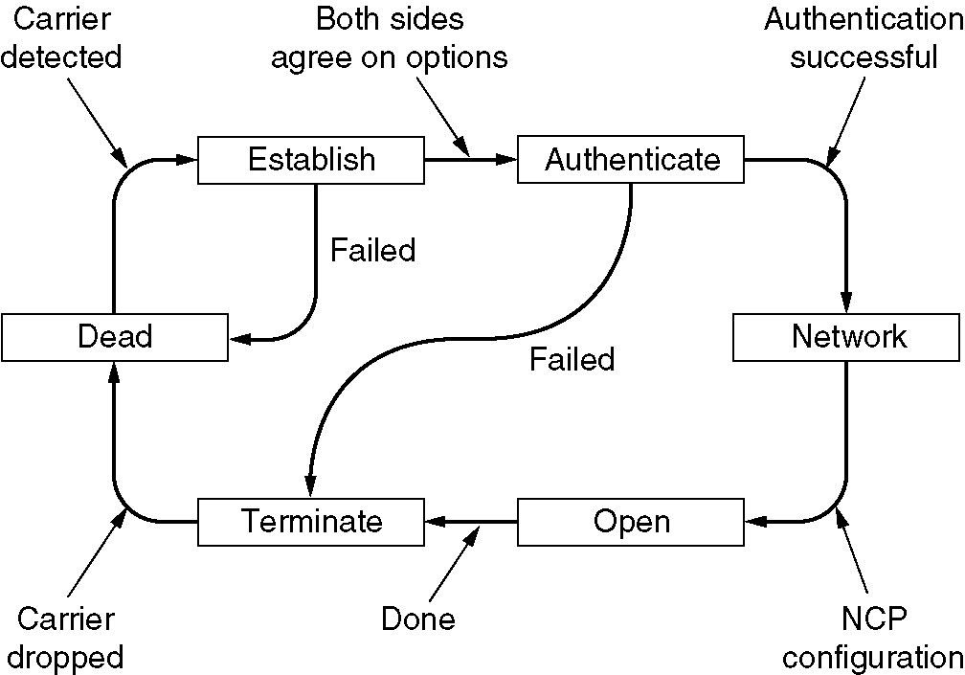

Figure : PPP State diagram

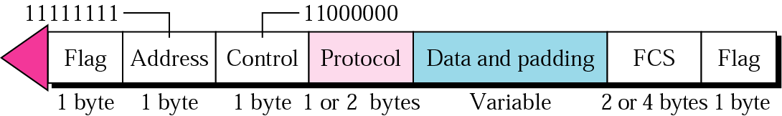

Figure : PPP Frame Layout

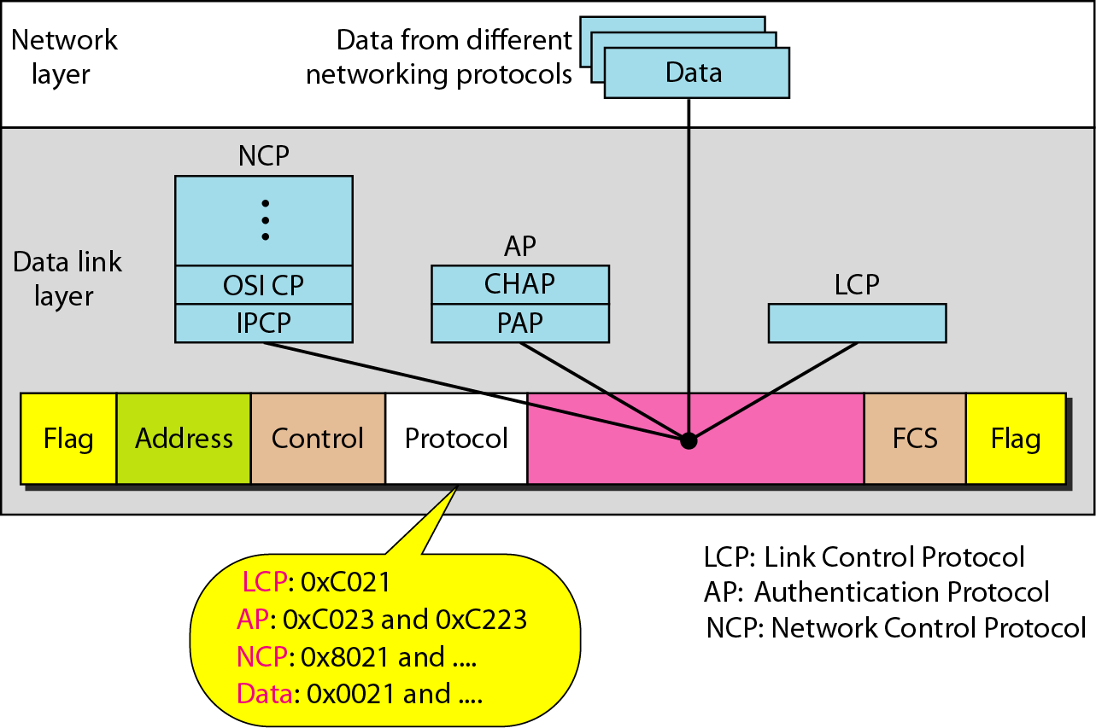

Figure : PPP Protocol byte

# Medium Access Control (MAC)

## Time Division Multiple Access (TDMA)

A network employing TDMA uses 50ms time slots. The available slots are split up between 6 stations. During a period of 3 seconds, stations 1, 5 and 6 have data to transmit. Calculate the usage of the available bandwidth for TDMA with and without a reservation access method. Assume that it takes 60us for the reservation frame to be transmitted and that it is negligible in the calculation of the bandwidth usage. Demonstrate the usage in a diagram.

## Carrier Sense Multiple Access (CSMA)

Both, CSMA with Collision Detection (CSMA/CD) and CSMA with Collision Avoidance (CSMA/CA) use binary exponential backoff. Assume that four stations 1, 2, 3 and 4 want to send data and the transmission of a frame has just been completed. Show in a diagram how the four stations compete for the medium and the times that are involved, using both CSMA/CD and CSMA/CA.

## Poll

Assume that a wireless network consists of a wireless access point and a set of 6 mobile stations. The wireless access point polls the individual mobile stations for data to transmit. Stations 1, 3, and 4 have data to transmit; stations 2, 5 and 6 have no data to transmit. Show in a diagram the traffic that is exchanged over the wireless medium between the access points and the stations.

Figure 4: Binary Exponential Backoff

## Code Division Multiple Access (CDMA)

Assume a network with three mobile phones, stations 1, 2 and 4, and a base station, station 3. The three mobile phones want to send 011, 101 and 100 respectively; the base station is silent. A 0 is encoded as -1, a 1 is encoded as +1 and silence is represented by 0. Give the signal that the base station receives.

Chip Sequences:

Station 1: +1 +1 -1 -1

Station 2: +1 -1 +1 -1

Station 3: +1 +1 +1 +1

Station 4: +1 -1 -1 +1

## Example from an exam:

